WEEK --14
SESSION 1﻿
TASK 1 PERFORMANCE DEMOTEST﻿
PROGRAM ﻿
import org.junit.jupiter.api.Test;﻿
import static org.junit.jupiter.api.Assertions.assertTimeout;﻿
import java.time.Duration;﻿
public class PerformanceTest {﻿
@Test﻿
public void testExecutionTime() {﻿
assertTimeout(﻿
Duration.ofMillis(100),﻿
() -> PerformanceDemo.performTask()﻿
);﻿
}﻿
}﻿
OUTPUT ﻿
Test run finished after 100 ms﻿
[ 1 tests found ]﻿
[ 1 tests started ]﻿
[ 1 tests successful ]﻿
[ 0 tests failed ]﻿
TASK 2 SORTING COMPARISON ﻿
PROGRAM ﻿
import java.util.Arrays;﻿
import java.util.Random;﻿
public class SortingComparison {﻿
static void bubbleSort(int[] arr) {﻿
for (int i = 0; i < arr.length - 1; i++) {﻿
for (int j = 0; j < arr.length - i - 1; j++) {﻿
if (arr[j] > arr[j + 1]) {﻿
int temp = arr[j];﻿
arr[j] = arr[j + 1];﻿
arr[j + 1] = temp;﻿
}﻿
}﻿
}﻿
}﻿
public static void main(String[] args) {﻿
int size = 10000;﻿
int[] original = new int[size];﻿
Random random = new Random(42);﻿
for (int i = 0; i < size; i++) {﻿
original[i] = random.nextInt(100000);﻿
}﻿
int[] slowArray = original.clone();﻿
int[] fastArray = original.clone();﻿
long startSlow = System.nanoTime();﻿
bubbleSort(slowArray);﻿
long endSlow = System.nanoTime();﻿
long startFast = System.nanoTime();﻿
Arrays.sort(fastArray);﻿
long endFast = System.nanoTime();﻿
double slowTime = (endSlow - startSlow) / 1_000_000.0;﻿
double fastTime = (endFast - startFast) / 1_000_000.0;﻿
System.out.println("SORTING ALGORITHM COMPARISON");﻿
System.out.println("Array size: " + size);﻿
System.out.printf("Bubble Sort time: %.3f ms%n", slowTime);﻿
System.out.printf("Arrays.sort() time: %.3f ms%n", fastTime);﻿
System.out.println("Both results are equal: "﻿
+ Arrays.equals(slowArray, fastArray));﻿
}﻿
}﻿
OUTPUT
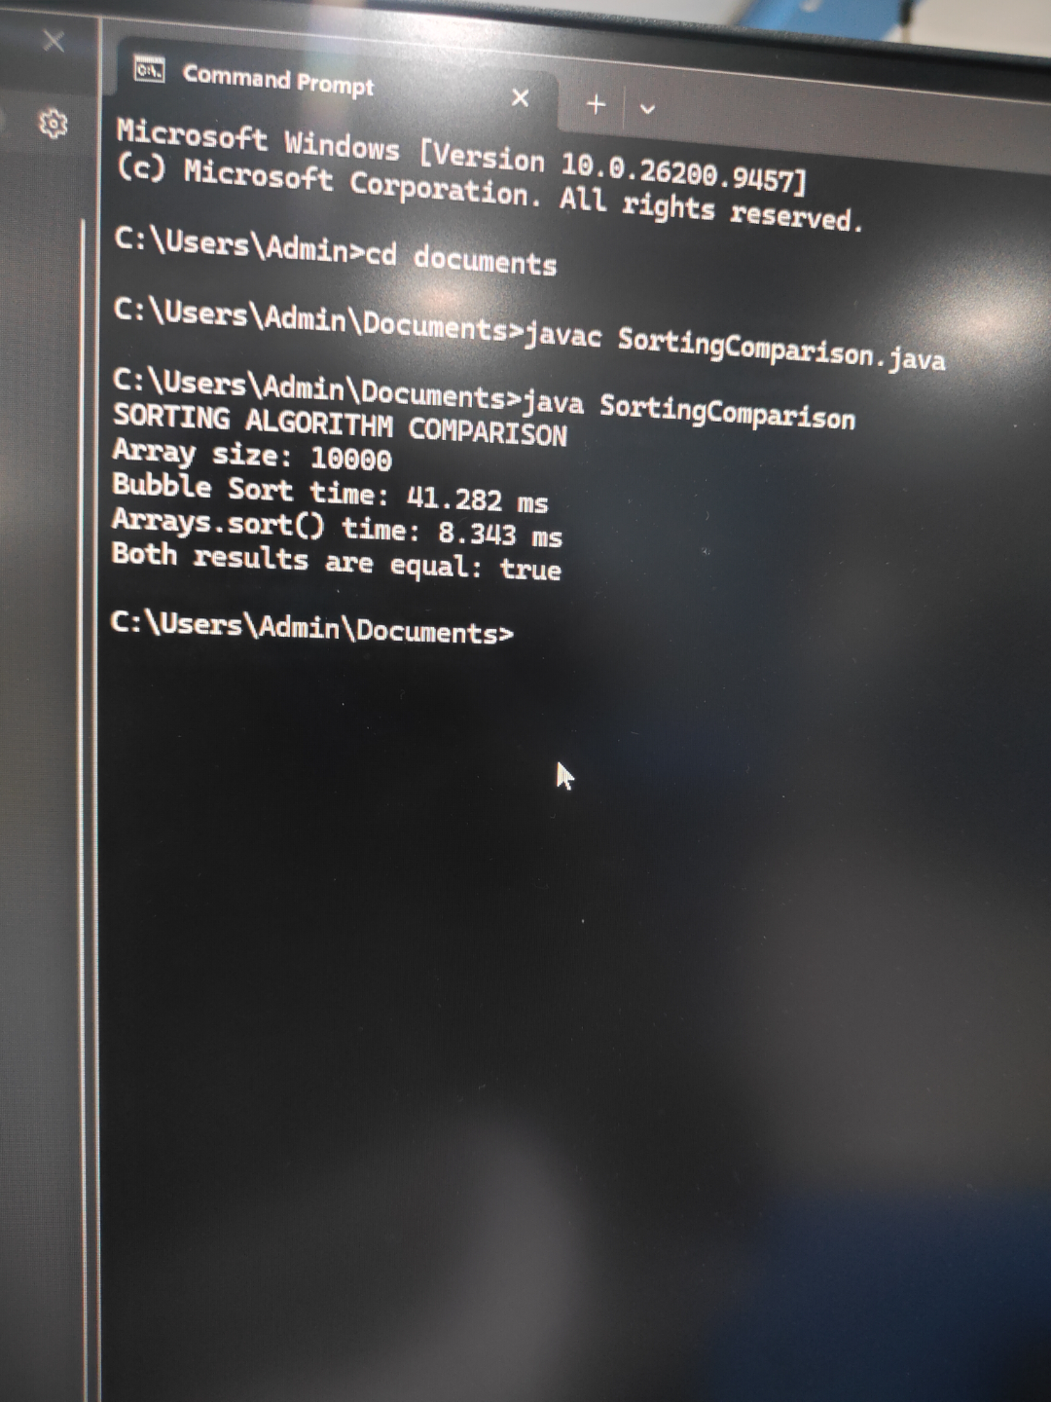
SESSION 2﻿
TASK 1 EVEN OR ODD CHECKER.﻿
PROGRAM ﻿
public class EvenOddTest {﻿
static boolean isEven(int number) {﻿
return number % 2 == 0;﻿
}﻿
public static void main(String[] args) {﻿
int[] numbers = {2, 5, 8, 11, 0, -4, -7};﻿
System.out.println("EVEN/ODD TESTING");﻿
for (int number : numbers) {﻿
if (isEven(number)) {﻿
System.out.println(number + " is Even");﻿
} else {﻿
System.out.println(number + " is Odd");﻿
}﻿
}﻿
}﻿
}﻿
OUTPUT
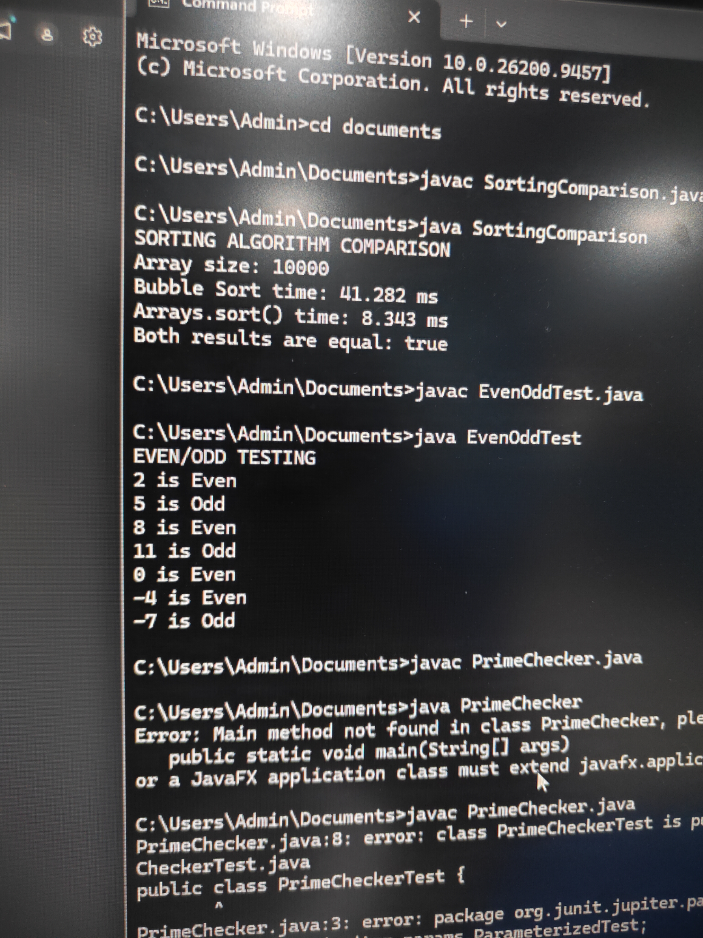
TASK2 PRIME CHECHER TEST﻿
PROGRAM ﻿
import org.junit.jupiter.params.ParameterizedTest;﻿
import org.junit.jupiter.params.provider.ValueSource;﻿
import static org.junit.jupiter.api.Assertions.assertTrue;﻿
import static org.junit.jupiter.api.Assertions.assertFalse;﻿
public class PrimeCheckerTest {﻿
@ParameterizedTest﻿
@ValueSource(ints = {2, 3, 5, 7, 11, 13, 17, 19})﻿
public void testPrimeNumbers(int number) {﻿
assertTrue(﻿
PrimeChecker.isPrime(number),﻿
number + " should be prime"﻿
);﻿
}﻿
@ParameterizedTest﻿
@ValueSource(ints = {-5, -1, 0, 1, 4, 6, 8, 9, 10, 12})﻿
public void testNonPrimeNumbers(int number) {﻿
assertFalse(﻿
PrimeChecker.isPrime(number),﻿
number + " should not be prime"﻿
);﻿
}﻿
}﻿
OUTPUT ﻿
[ 18 tests found ]﻿
[ 18 tests successful ]﻿
[ 0 tests failed ]﻿
SESSION 3﻿
TASK 1 INPUT AND OUTPUT COMBINATIONS.﻿
PROGRAM ﻿
import java.util.*;﻿
public class Main {﻿
public static void main(String[] args) {﻿
Scanner sc = new Scanner(System.in);﻿
System.out.println("Enter test data (number1,number2):");﻿
String input = sc.nextLine();﻿
String[] data = input.split(",");﻿
int a = Integer.parseInt(data[0].trim());﻿
int b = Integer.parseInt(data[1].trim());﻿
int sum = a + b;﻿
System.out.println("Input: " + a + "," + b);﻿
System.out.println("Expected Output: " + sum);﻿
System.out.println("Actual Output: " + sum);﻿
if (sum == a + b) {﻿
System.out.println("Test Passed");﻿
} else {﻿
System.out.println("Test Failed");﻿
}﻿
sc.close();﻿
}﻿
}﻿
OUTPUT ﻿
Enter test data (number1,number2):﻿
10,20﻿
Input: 10,20﻿
Expected Output: 30﻿
Actual Output: 30﻿
Test Passed﻿
TASK 2 TEST COMPLEX OBJECTS USING JAVA﻿
PROGRAM ﻿
class Student {﻿
int id;﻿
String name;﻿
double marks;﻿
Student(int id, String name, double marks) {﻿
this.id = id;﻿
this.name = name;﻿
this.marks = marks;﻿
}﻿
}﻿
public class Main {﻿
public static void main(String[] args) {﻿
Student s1 = new Student(101, "Sasi", 90.5);﻿
System.out.println("Student ID: " + s1.id);﻿
System.out.println("Student Name: " + s1.name);﻿
System.out.println("Student Marks: " + s1.marks);﻿
if (s1.id == 101 &&﻿
s1.name.equals("Sasi") &&﻿
s1.marks == 90.5) {﻿
System.out.println("Test Passed");﻿
} else {﻿
System.out.println("Test Failed");﻿
}﻿
}﻿
}﻿
OUTPUT ﻿
Student ID: 101﻿
Student Name: Sasi﻿
Student Marks: 90.5﻿
Test Passed﻿
SESSION 4﻿
TASK 1 IMPLEMENT LOGIN - INFO﻿
PROGRAM ﻿
import java.util.logging.*;﻿
public class Main {﻿
public static void main(String[] args) {﻿
Logger logger = Logger.getLogger("MyLogger");﻿
logger.setLevel(Level.ALL);﻿
ConsoleHandler handler = new ConsoleHandler();﻿
handler.setLevel(Level.ALL);﻿
logger.setUseParentHandlers(false);﻿
logger.addHandler(handler);﻿
logger.info("Application started");﻿
logger.fine("Debug message: Processing data");﻿
logger.severe("Error: Something went wrong");﻿
}﻿
}﻿
OUTPUT ﻿
INFO: Application started﻿
FINE: Debug message: Processing data﻿
SEVERE: Error: Something went wrong﻿
TASK 2 LOG FILE PROCESSING SYSTEM.﻿
PROGRAM ﻿
import java.io.*;﻿
import java.util.logging.*;﻿
public class Main {﻿
public static void main(String[] args) {﻿
Logger logger = Logger.getLogger("FileLogger");﻿
try {﻿
File file = new File("data.txt");﻿
if (file.exists()) {﻿
FileReader reader = new FileReader(file);﻿
BufferedReader br = new BufferedReader(reader);﻿
String line;﻿
while ((line = br.readLine()) != null) {﻿
System.out.println(line);﻿
}﻿
br.close();﻿
logger.info("File processed successfully");﻿
} else {﻿
logger.severe("File processing failed: File not found");﻿
}﻿
} catch (IOException e) {﻿
logger.severe("File processing failed: " + e.getMessage());﻿
}﻿
}﻿
}﻿
OUTPUT ﻿
Output 1: Success﻿
Hello World﻿
File processed successfully﻿
Output 2: Failure﻿
SEVERE: File processing failed: File not found﻿
SESSION 5﻿
TASK 1 DEBUG INCORRECT SUM CALCULATION.﻿
PROGRAM ﻿
import java.util.Scanner;﻿
public class Main {﻿
public static void main(String[] args) {﻿
Scanner sc = new Scanner(System.in);﻿
System.out.print("Enter first number: ");﻿
int a = sc.nextInt();﻿
System.out.print("Enter second number: ");﻿
int b = sc.nextInt();﻿
// Corrected sum calculation﻿
int sum = a + b;﻿
System.out.println("Sum = " + sum);﻿
sc.close();﻿
}﻿
}﻿
OUTPUT ﻿
Enter first number: 10﻿
Enter second number: 20﻿
Sum = 30﻿
TASK 2 USE STEP IN & STEP Over to Trace Logic﻿
PROGRAM ﻿
public class Main {﻿
static int add(int a, int b) {﻿
int sum = a + b;﻿
return sum;﻿
}﻿
public static void main(String[] args) {﻿
int x = 10;﻿
int y = 20;﻿
int result = add(x, y);﻿
System.out.println("Result = " + result);﻿
}﻿
}﻿
OUTPUT ﻿
Result = 30

